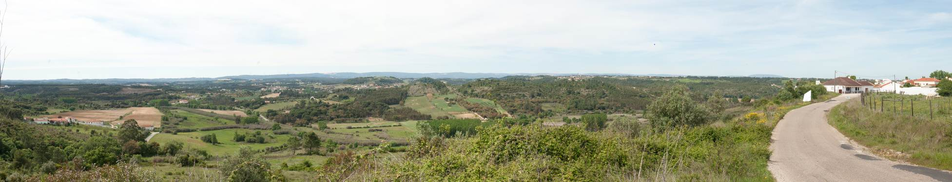
EVALUATION MEETING
“WHASSUP WITH YOU^{(TH EXCHANGES)}“
26-30 June 2013
Vila da Marmeleira - Portugal
APPLICATIONFORM
Full name:
Gender:
Birthdate:
Country of residence:

CONTACT DETAILS

Primary email to be contacted:
Phone on which you can be contacted:

ORGANISATIONAL INFORMATION

Please give some additional information of the organisation supporting you to participate in this evaluation meeting.
Name:
Address:
Email:
Tel/fax (if applicable):
What kind of organisation are you involved in (NGO?, Local Authority?, …):

What is the main aim of your organisation:

Give some examples of the main activities done by your organisation:

Please describe briefly your role within the organisation:

EXPERIENCE & MOTIVATION
Explain how you have used the action 1.1/3.1 (youth exchanges) as an instrument and as part of the strategic plan within your organisation (please summarize till maximum 250 words):

What are your personal aims and expectation for this evaluation meeting?
PRACTICALITIES

Please specify any food requirements that you have (vegetarian, etc) (optional)

Please specify any special requirements (mobility, medical conditions etc)

DECLARATION AND FURTHER COMMENTS

If there is other information that you think we might need, please write it here. Please take note of the following conditions that will apply if you are selected to take part in this evaluation meeting. 1. I commit myself to participate to the whole process, including: * to prepare myself carefully for the evaluation meeting and to do all the needed remote preparation work * to participate in the whole evaluation process 2. I am aware that obtaining a health and a full travel insurance are my own responsibility of ensuring my own health. 3 I authorise the involved National Agencies and the host organisation to publish in whatever form and whatever medium pictures taken at the evaluation meeting, with the purpose of further promotion of European mobility programmes.

Any comment for your side:

APPLICATION DEADLINE IS 15TH OF MAY AND YOU WILL BE NOTIFIED WITHIN DAYS AFTER IF YOU HAVE BEEN SELECTED OR NOT.

Send this filled in application form ASAP to:
For participants of programme countries (eligible countries mentioned in below grid)
NA Finland | Paavo.Pyykkonen@cimo.fi & Ossi-Pekka.Ollikainen@cimo.fi
NA Ireland | lgilligan@leargas.ie
NA Denmark | MK@ui.dk & JERA@ui.dk
NA Norway | gry.nesse@bufdir.no
NA Belgium (FR) | anne.demeuter@cfwb.be
NA Sweden | liene.ledaine@ungdomsstyrelsen.se
NA Portugal | carla.marques@juventude.pt & joaquim.freitas@juventude.pt

For applicants of the neighbouring countries:
Jo Claeys on elinfluence@hotmail.com (You will receive a confirmation of receiving)

