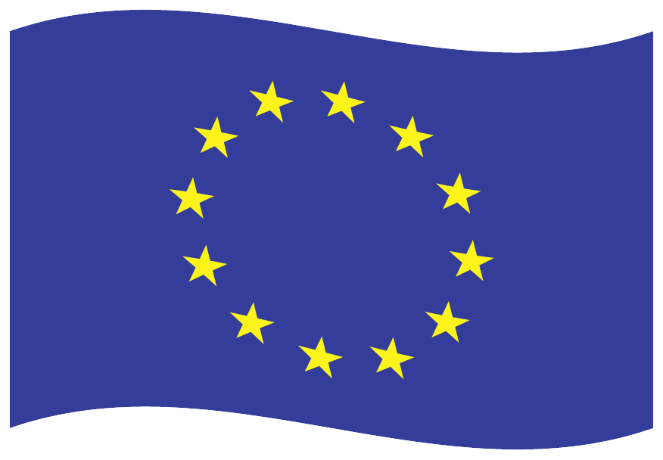
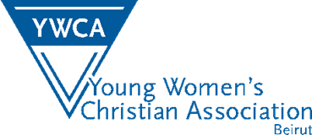
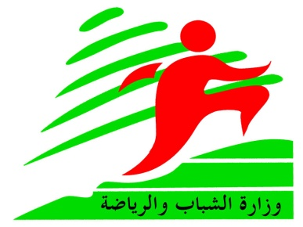
This project is financed by the
EUROPEAN UNION- EUROMED, Youth in Action Programme

“Be Brave: Express yourself"
16-21 November 2013, Beirut-Lebanon

APPLICATION FORM

 |  |  |  | Personal info
 |  |  |  |  | Family name:
 |  |  |  |  | First name:
 |  |  |  |  | Post Address:
 |  |  |  |  | Phone:
 |  |  |  |  | Fax:
 |  |  |  |  | E-mail:
 |  |  |  |  | Birth date:
 |  |  |  |  | Nationality:
 |  |  |  |  | Residency:
 |  |  |  |  | Passport No.:
- Organization name & Address:
- 3 Lines about yourself:
- Language skills:
Native language:
 |  |  | Fluent |  |  | Good |  |  | Enough |  | Poor
English
Please note that the working language of this training course going to be English.

- Please tell us about your motivation to participate in this training:
- Do you have a previous international experience? If yes, please describe:
- What experience do you have in the women empowerment topic?
- How can you contribute during this training?
- What kind of things you don't like to encounter during this training?
- What knowledge, skills, and competences you hope to gain during this training?

- How do you think you’d use your knowledge, skills and experience obtained during the training when you are back?
- Any special needs or requirements you would like to have regarding food or accommodation?
- Any remarks you would like to share with the organizers?

I approve/ do not approve that pictures taken of me during the training would be put on the website of the training course and any other publication meant for dissemination on the results. (please underline)

- This project is supported by the Youth in Action Programme.
- The organizers will cover 100% of the costs for visa, accommodation, food and programme activities and 70% of the travel expenses for participants.
- Please send back this application to beirut2@lebanonywca.org

Date |  | Signature:

Emergency contacts:
Name:
Phone:
Address:
E-mail Address:
Relation to participant:

