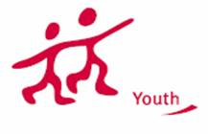
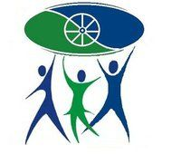
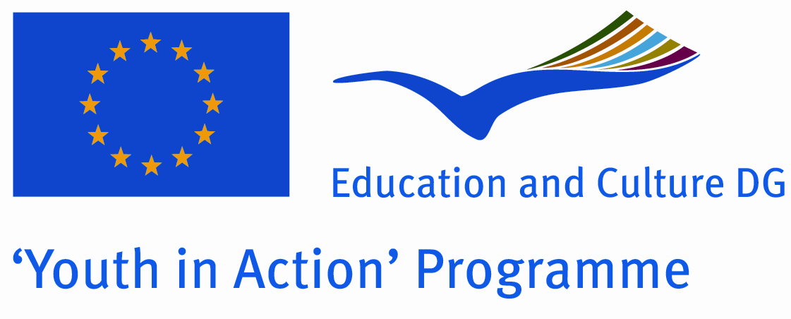

INFO PACK
FOR THE TRAINING COURSE

“Minority youth against gender inequality”

Date: 04 - 12 of July 2014
Venue: Stuga, Macedonia
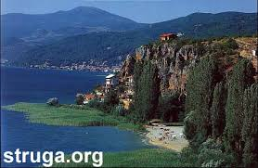

Short summary
The poorest communities in almost any region tend to be minority communities that have been targets of long-standing discrimination, exclusion and sometimes violence. Women and girls from minority groups experience multiple and intersectional forms of discrimination based on both their minority status and their gender.
Minority women frequently experience multiple forms of oppression, and the oppression can vary depending on who she is dealing with (e.g. her minority community, majority community, institutions, etc.). Gender is a social, not a biological concept . Differences in gender roles and behaviors often create inequalities, whereby one gender becomes empowered to the disadvantage of the other.
Related to our work with young people, we noted that gender equality still has place for development in order to break down all the taboos with gender issue. Gender violence is the most dullness apparition in practice. This problem needs as soon as to get action for promoting the prevention. For that purpose, it is necessary to connect young people with different background to work together on this issue.

Objectives:
- to empower and develop the participants `competence in gender mainstreaming and gender based violence;

- to Introduce the concepts and methods of minority and women rights used in youth work promoting women participation from the local level to the national and European level;

- to promote different approaches to intercultural learning and gender based violence related with participants’ experiences;

- to develop practical approaches and methods for translating gender equality, gender based violence and human rights education into youth work practice within the minority communities;

- raise the awareness on gender issue and stimulate participants to act as multiplayer in minority communities;

- to develop a strong network and possibly plan future cooperation project.

Methodology

The course is designed as a mutual learning session, where participants can experience and compare different approaches to:
• Gender equality within the minority communities;
• Youth work with/for minorities` women;
• Gender based violence;
• Employment discrimination facing minorities` women.

The method we will use is 'learning by experience '. Participants will participate in activities related to gender equality, minority, gender based violence, social construction, the concrete aspects in working with minorities` women, employment discriminating facing minorities’ women, the importance of minorities` women participation. Different NFE methods: group in the small group, buzz group, role play, case study, open space?
The course programme will also provide participants with the opportunity to develop their ability to contribute to the sustainability of minority youth organizations, including democratic and shared leadership, empowering and motivating volunteers, bringing democratic and quality decisions, development of organizational strategies and organizational learning.

Costs
The hosting organization will cover full board and lodging costs, and 70% of travel costs, after providing original invoices, tickets, boarding passes…

Participation fee: 20 € which will be taken from the travel money

Venue

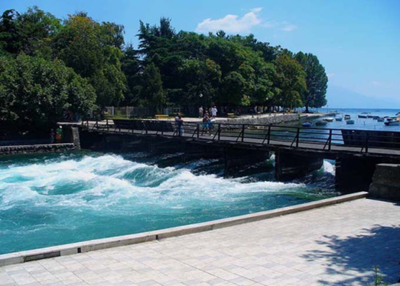
Participants will be accommodated in hotel Ambient in Struga. Here is more information for the town:

Struga & Macedonia
Struga is a town in the western part of the Republic of Macedonia, lying on the shores of Lake Ohrid. The town is located on the coast of the magnificent Lake Ohrid and along the banks of the river of “Black Drim”, which flows right out of the lake splitting the city into three sections.
Struga is also a place of important cultural significance in the Republic of Macedonia, as it is the birthplace of the poet Konstantin Miladinov. The main event of the cultural life in Struga is the world`s largest poetry gathering, Struga Poetry Evenings, attended every year by at least 200,000 people from all over the world. The festival inter alia bestows a Golden Wreath adomed with diamonds, sapphires and rubies, the highest award for one`s overall poetry work. Matching shoes are also awarded to the winner. There are several cultural monuments in Struga and in its vicinity such as the Monastery of Kalishta, a few kilometers away from the town center, laying on the shore of Lake Ohrid. It is believed that it dates from the 16h century, with frescos from 14th and the 15th centuries. The church Sveta Bogorodica (St. Mary) in the village of Vranishta, is believed to be the one where Tsar Samuil was crowned. The church has many doors and far fewer windows and often the people call it “the kings church”. The church of St. George is also located in the town; built on top of Samuil`s Church, it has many icons from the 14th, 15th, and 16th century. Near the village of Ladorishta, a basilica from the 4th century has been discovered, with a Mosaic. Struga`s old architecture, dating from the 18th and 19th century is also a cultural highlight.

More info about Macedonia on www.exploringmacedonia.com

How to apply
All you need to do is to be INTERESTED, MOTIVAED and to send us your application form on the following e-mail:

contact.youthhope@yahoo.com

no later than 06th June 2014.

In subject please write: TC-MW-(your country)

GOOD LUCK

