DIG-IT up!

2-7 May 2015
Rome, Italy

Call for participants

General Overview of the Training Course:
Youngsters deal more and more with technology, internet and mobile devices. Most often they watch videos, listen to music and have full time access with their friends. They see themselves mostly as consumers of digital media but not so much as creators of digital material, even though thousand of pictures are put on Instagram and short movies are shared every day.
Adults fear that youngsters lose their time, contact with the “real” world and social competences while staring into their screens. Many adults have a hard time understanding or appreciating digital skills youngsters have and their motivation to be constantly online. That often leads adults to ban digital devices, close themselves from getting to know new digital tools and very likely get into conflicts with youngsters. Are we, as adults, as youth workers, ready to learn and use tools youngsters know and additionally find creative ways to include them in our work?
With this TC we are proposing solutions that value the needs of both sides and support communication between them by looking for ways youth workers keep on track with “digital youngsters” and include digital devices into their work: being online as a developmental tool to foster digital creativity.
If you:
- believe that it’s important and pedagogically useful to deal with digital devices,
- want to give your digital skills an upgrade and
- start including a digital attitude in your youth work
then apply for DIG-IT up! Training course on including digital tools in Youth work!

Objectives:
The aim of this training course is to provide new knowledge and skills and find creative ways on how to combine analog & outdoor activities in youth work with digital tools and applications that are used by youngsters through a hands-on approach and experience:

• getting familiar and friendly with popular applications and digital tools, such as: #, QR Code, Instagram, Pinterest, Twitter, FB, Geocashing, lipdub, Whatsapp.

• experiencing and learning how to use various spaces (open-air, analog/digital) to create a supporting learning environment.
• building a positive and open attitude towards new technologies and the use of internet as a tool that facilitates effective collaboration with young people

• bringing people of different (professional) backgrounds together to share experiences with digitalized youth and to develop creative digital methods for youth work
The expected outcomes:
During this TC we will work with a wide spectrum of tools and applications to experience creative and funny ways of using them and also prepare participants to develop their own ideas for new methods to apply them during the final session. The participants are invited to find comprehensive educational aspects of digital tools in youth work with the aim of including youngsters.

Methodology:
Using the gamification approach (that is, transforming a learning experience in a game, often borrowing rules, points etc from video-games themselves) we propose 4 full working days of activities in a group of youth workers and trainers from around Europe. Our challenge is doing it either online and offline, to prove and learn that there is not such a difference between these two worlds, they can talk to each other, and the activities we offer to our youth can start in one, continue in the other one and go back to the beginning, keeping an identity and a meaning.
We offer a learning-by-doing experience, or a hands-on approach, in the hackers’ slang: all participants will be driven into games, activities, treasure hunts, multimedia creations etc to learn techniques and approaches involving open air-and online worlds. Participants will discover the fun factor of including these tools in their youth work.

Additionally we want to bring on a discussion and reflection on the impact of social media on youth education, through input coming from TED-talk videos, sharing of experiences and best practices.

We are open to different levels of knowledge and use of the technologies, and we will gather information on this before the actual activity through an online survey and quiz-activities/ games to be run inside the participants’ facebook group, before the meeting.

Participant Profile:
The target group is youth leaders, youth workers and trainers, willing to enhance their competences, flexibility and readiness in using digital devices, online mode and social media in their youth work.
We are looking for people who work with young people and:
- who know just the names of applications mentioned above, are digital-shy and don’t know what they mean,
- who use those apps fluently, but are willing to find out what more could be done with them,
- who are able to communicate and work in English (which will be the working language for the whole training course).
- who are able to attend the full training course.

- who wish to learn and teach others during discussions or peer evaluation.

- Who are willing to share and use the learning outcomes of the TC in their organizations and with young people.
Venue:
The training course will be in Rome, Italy, from May 2nd (arrival day) to May 7th (departure day).

Application procedure & deadline:

Please apply online through SALTO website not later than the 22nd of March 2015. Your National Agency will do the pre-selection.

If your application is accepted, you will receive a confirmation and further information as soon as possible after the 26th of March 2015. Please do not book any tickets before you receive confirmation of your participation.

Financial Conditions:
- This project is financed by the Erasmus + Programme, and organized by the Italian National Agency with the support of Polish, Austrian and Greek, National Agencies.

- Board and lodging will be provided and paid by the Italian NA.

- Participants coming from Programme Countries: travel costs will be covered by your National Agency according to their own rules (please check before applying).

- Any insurance, especially a medical one, is a private responsibility of each participant.

What to have with you during a training and preparation phase:

A facebook account will be needed to join the GB group and take part in the online preparation activities.

For a training please bring:
- a mobile device (phone/tablet) able to connect to wifi and to insert a phone/sim card (provided by the team) to have mobile connection during activities.
- an USB drive to save work documents - products - documentation.

Draft programme:

Saturday, May 2nd | Sunday, May 3rd | Monday, May 4th | Tuesday, May 5th | Wednesday, May 6th | Thursday, May 7th
Arrivals | Morning:
 | Exploring the TC:  Intro, interests, expectations…  Introduction to Youthpass | Get to know your device  Introduction to geocaching | Lipdub production pt.1 | Digital creative action:  Do your thing outside | Departures
 | Afternoon:
 | Digital City Game | The adventure of geocaching | Lipdub production pt.2  Introduction to digital promotion of activities | Dissemination the digital way  Youthpass & evaluation of TC
Evening: | Evening:
Getting to know each other | Passion Hashtag evening:  Instagram etc. |  |  | Red carpet party with screening of lipdub productions

The team (aka: who are we?)
This training course is the result of our participation in SALTO Trainer of Trainers (TOT) course in 2014-15. Groups of 4 participants had to define together their Training Practice Projects (TPP) and this is our group:

Argyris Choulias – Greece, Joanna Wronska – Poland,
Michele Di Paola – Italy, Raphaela Blassnig – Austria

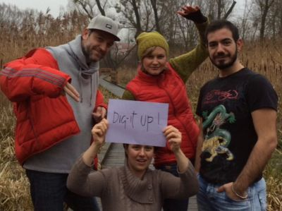
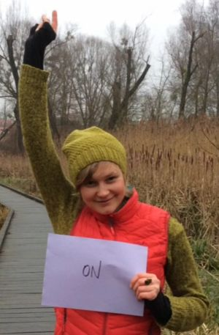  Raphaela | Joanna  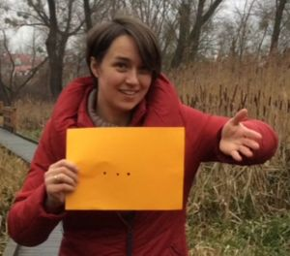 | 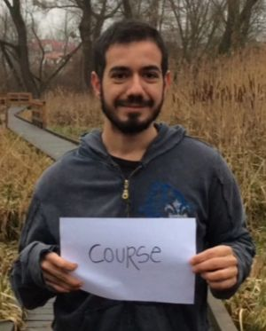  Argyris | 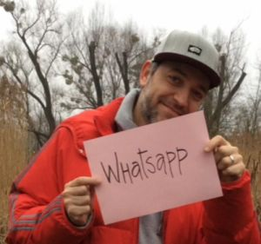  Michele

Watch training’s trailer: http://youtu.be/i6QrJSVFSmE

Take part in our online survey:
https://docs.google.com/forms/d/1jsw25nSjXb4hXGOgxE0XDPYZ1TbfX7YrCHWk5GRNU7I/viewform

For more information, please contact Mrs. Fabiana Di Carlo (f.dicarlo@agenziagiovani.it) from Italian National Agency or our team: digitup2015@gmail.com

