TRAINING COURSE
KA1 MOBILITY OF YOUTH WORKERS
17RD – 24TH MAY

KALEIDOSCOPE
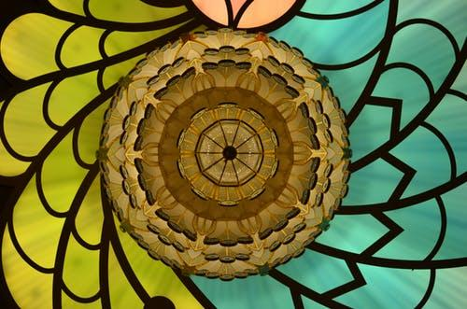
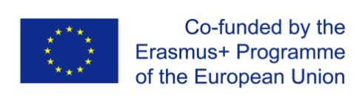
ORGANISED BY FUNDED BY
PROJECT SUMMARY
Kaleidoscope is a training programme designed to give youth workers (professional and volunteer) the confidence and competence to explore the Sustainable Development Goals (SDGs) and citizenship with the young people they work with. The connections between Global Youth Work and the Erasmus+ Programme form the essence of the Kaleidoscope training course. The training course draws inspiration from the One World Citizens (OWC) training course which was created and developed by the same trainers. Following on from the experience and evaluation of two OWC trainings, it seems reasonable to organize a next opportunity for practitioners within the Erasmus+ programme to take part in a training course exploring global issues, and their impact on young people. We wish to carry out this project for two reasons. Firstly, we are living in more globalised and interconnected world. This new context warrants a reinforcement of solidarity and active citizenship. Additionally, with the increasing trend of extremism globally, there is a need for a reinforcement of values related to this project and global citizenship in general such as sustainability, equality and peace.

OUR GOALS AND OBJECTIVES
- Examine the relationship between European citizenship and global citizenship
- Build skills, knowledge and attitudes related to addressing the Sustainable Development Goals (SDGs), particularly Goal 4 – Quality Education
- Explore a variety of methodologies related to tackling the SDGs
- Allow a space for participants to design their own SDGs activities

PARTICIPATING COUNTRIES AND PARTNER ORGANISATIONS
We will welcome a total of 28 participants from 9 different countries. Below you can find each country along with the sending organisation and number of places available:
Participating Country | Partner Organisation | Places Available
IRELAND | Development Perspectives | 4
ITALY | Cooperativa Mouvimente Sociale | 3
CYPRUS | Future Worlds Centre | 3
ROMANIA | Asociatia Be You | 3
UK | Think Forward | 3
SLOVENIA | Humanitas | 3
PORTUGAL | Agoraveiro | 3
GERMANY | Eine Welt | 3
CZECH REPUBLIC | Cia Cekija | 3

OUR TEAM OF TRAINERS
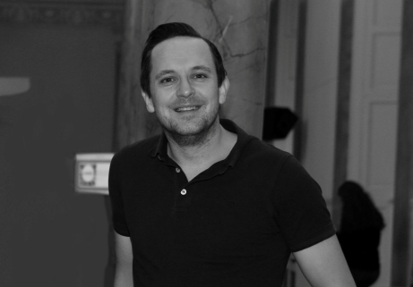
PAUL CREWE
(IRELAND)
Paul Crewe holds a B.A Honours degree in Community Sports Leadership and has been working with Development Perspectives since 2013 as a project coordinator. Paul has been involved in projects in Ireland, Italy, Germany, the Netherlands, Vietnam, Fiji and Tanzania. He has been involved in both development education and employability projects with Development Perspectives. Paul also has experience in dealing with training course logistics, facilitation and preparing funding applications.

STEPHANIE KIRWAN
(IRELAND)
Stephanie Kirwan has been involved with Development Perspectives since 2011 and coordinates the #SDGchallenge. Stephanie is undertaking her MA in International Development in the University of Maynooth and is passionate about the role development education plays in achieving the Sustainable Development Goals. Stephanie is a registered Health Promotion Officer through the APHI. In her spare time she enjoys travelling, juicing and regularly updating her Instagram.

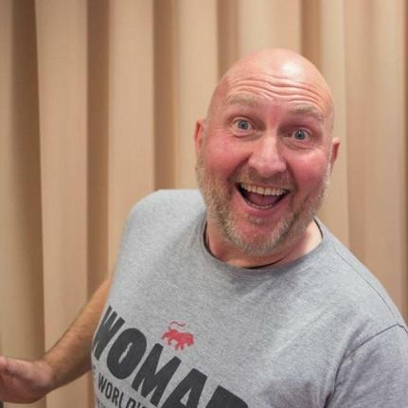
BUZZ BURY
(UK)
Buzz Bury is a youth worker from Blackpool, UK with vast experience coordinating and training on Erasmus+ and, formerly, Youth in Action projects throughout Europe. Buzz is experienced in using creative non-formal methods in global youth work, inclusion work (through music) and multicultural learning.

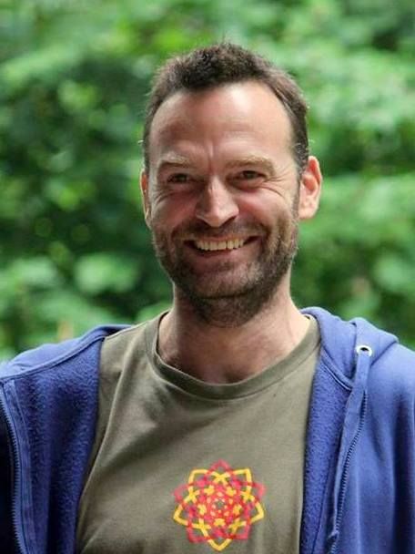
JAN LÁTAL
(CZECH REPUBLIC)
Jan Látal is active in education and training since 2002. Recently works as a nature guide and ritual designer, uses natural elements in coaching and self development. For 10 years he was member of pool of trainers for Czech National Agency for Youth in Action/Erasmus+ programme, nowadays continuing in Austrian National Agency. Interested in religions and cultures, loves connecting nature, art and spirituality in learning.

DISSEMINATION
Dissemination is a very important aspect of Erasmus+ projects. It increases the visibility and impact of the project by providing an opportunity to share outcomes with wider audiences.
You will be required to actively take part in dissemination activities during and after the project. We will provide more detail and offer space for this during the training course.

ACCOMMODATION
The project will take place in Castle Saunderson International Scout Centre (pictured below). The centre is located near the small town of Belturbet, County Cavan and is situated next to the castle ruins previously owned by the Saunderson family.
This accommodation is regularly used for our training courses. There are multiple training rooms and work spaces, a huge open/chill out space complete with a fireplace and a kitchen and dining room in the lower floor. The upper floor contains bedrooms and showers (2 male and 2 female). 3-6 people will be accomodated in each room.

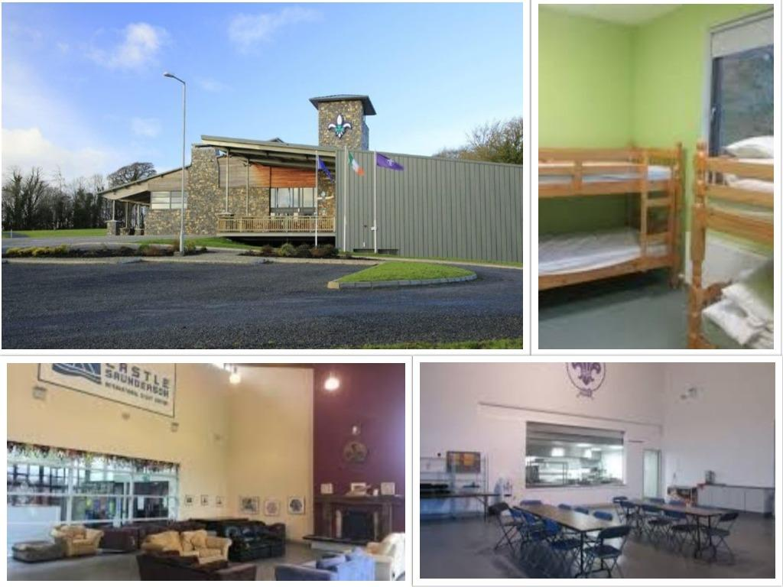
The house will be self managed by the group during the course. This aligns with our educational approach which encourages sharing, responsibility and development of community spirit. Participants will share responsibility for everyday tasks such as washing up, cleaning and sorting garbage.
Food will be prepared by our staff who have vast experience of preparing food for large groups. In an effort to promote sustainability, the menu will be vegetarian with efforts made to use local produce where possible.
ARRIVALS AND DEPARTURES
As it takes some time to get to the venue from the closest airport, we would ask you to arrange your arrival in the morning hours. The programme will start at 7pm on May 17th.
The end of the programme is scheduled for May 23rd. There is no programme planned for the departure day – May 24th. So you can leave the venue in the morning as early as you want. The entire group must leave the venue by 10:30am.
If you are travelling by plane you should fly to Dublin airport. From there you can take the 30/X30 bus (Dublin – Donegal). You can catch this bus at Zone 11 outside the airport. If you take the 30, you should get off at “Belturbet”. The X30 does not stop there, so if you take the X30 you should get off at “Cavan”.
It is slightly cheaper to buy a ticket online than at the station or from a driver. Please note that drivers will only accept cash. Tickets can be bought on the Bus Eireann website: http://www.buseireann.ie/
You can check bus timetables here: http://www.buseireann.ie/inner.php?id=406&form-view-timetables-from=&form-view-timetables-to=&form-view-timetables-route=30&form-view-timetables-submit=1
We have staff that will be able to collect you from the bus station and take you to the venue. We will organise collection times the week before the course.
Our programme will include a free half day with the option for people to spend 2-3 hours in Cavan town. No trips to Dublin or other larger cities will be organised. You can take extra days to organise and visit these places at your own leisure. You can take 2-3 days (before or after the course) and still be eligible for a travel reimbursement (not more). Accommodation costs and other expenses for extra days cannot be covered due to the financial rules of the grant.
TO BE ABLE TO ATTEND THE COURSE FROM BEGINNING TO END IS ONE OF THE BASIC CONDITIONS FOR PARTICIPATION. SO PLEASE ARRANGE TO BE THERE ON TIME. IN CASE OF ANY COMPLICATIONS, PLEASE LET US KNOW AS SOON AS POSSIBLE.

TRAVEL REIMBURSEMENT
The course is co-funded through the Erasmus+ European programme. We can reimburse only the cheapest transportation possible and only public transport 2nd class fares. Taxi is not refundable, as well as private cars. For the reimbursements, we will need:

1. An invoice with the itinerary of your trip, the names of the passengers and, very important, the price of the ticket. Usually all this information is available on the e-tickets for flights.

2. All your original travel tickets and receipts (train and bus tickets) which you wish to have reimbursed. We cannot provide reimbursement without the originals of these documents, so it is your responsibility to take care of them.

IMPORTANT: WE CAN ONLY REIMBURSE YOUR FLIGHTS IF YOU PRESENT US WITH YOUR BOARDING PASSES! IF USING A MOBILE BOARDING PASS, PLEASE REMEMBER TO SAVE THEM OR TAKE A SCREENSHOT AS THEY AUTOMATICALLY DELETE THEMSELVES AFTER SOME TIME

The following list shows how much is the maximum allowed per person for a full return journey (two ways), so please try NOT to spend more than this:
IRELAND | €0
UK | €180
ITALY, PORTUGAL, SLOVENIA, CZECH REPUBLIC, GERMANY | €275
ROMANIA | €360
CYPRUS | €520

IMPORTANT: to determine where you are from, RESIDENCE is the counting factor, not nationality. This means that we can support the participation of somebody living in Italy (or Greece, Slovenia, etc), AS LONG AS YOU TRAVEL TO AND FROM THE COUNTRY, no matter what nationality is shown on your passport. Please don't ask for exceptions ("I'm originally from Czech Republic but now I live in Iceland can I travel from there?"), these are the rules and we cannot change them!
The reimbursement will be done after the end of the project, after we successfully get all the tickets and boarding passes also from your trip back home. Please allow 4-6 weeks while we process all the documents and organise the transfers. More information about when and where to send the tickets, and the relevant reimbursement form will be given during the training course.

TRAINING FEE
The participation fee for this course is €50. For participants outside Ireland, this fee can be paid by cash on arrival. For Irish participants, this fee must be paid by bank transfer upon selection for the programme in order to secure your place.

USUAL INFORMATION
- Irish sockets have different standards to most parts of Europe so you will likely need a travel adapter for your electronic devices. More info can be found here: https://www.power-plugs-sockets.com/ie/ireland/
- Irish weather can be famously unpredictable. We may have a week of beautiful sunshine or many days of heavy rain and strong winds. Please pack with this in mind as we hope to be working outside during this project
- Internet is available at the venue, but the signal can sometimes drop. Do not plan important online meetings or deadlines during this course. The course will be quite packed anyway
- PARTICIPANTS COMMIT THEMSELVES TO PARTICIPATE FULLY IN THE ENTIRE PROCESS, INCLUDING: TO READ ALL INFORMATION CAREFULLY, TO COMMUNICATE IN A TIMELY MANNER WITH THE ORGANISERS, TO PREPARE ADEQUATELY FOR THE TRAINING COURSE, TO ACTIVELY PARTICIPATE DURING THE TRAINING COURSE, TO SUPPORT EVALUATION AND DISSEMINATION EFFORTS DURING AND AFTER THE COURSE
- The participants are responsible for ensuring they have adequate travel and medical insurance
- Pictures, images and videos taken during the course can be used to document the activities in reports, websites, promotional materials or social media platforms
- Providing information on special needs does not remove the participant’s responsibility for ensuring their own health and safety

APPLICATION PROCESS
Participants must complete an application form to be considered for selection to the training course. The application form can be found here:
https://goo.gl/forms/1LhLhgwJLpVVivdz2
The Application deadline is April 2nd. After the selection and confirmation of attendance, participants will have 1 week to book their travels, and send us confirmation of their travel. Irish participants will be required to pay their €50 participation fee before the project to secure their place.

CONTACTS
In case of any questions, please contact us at: dperasmustrainings@gmail.com
or
+353 85 825 2744

