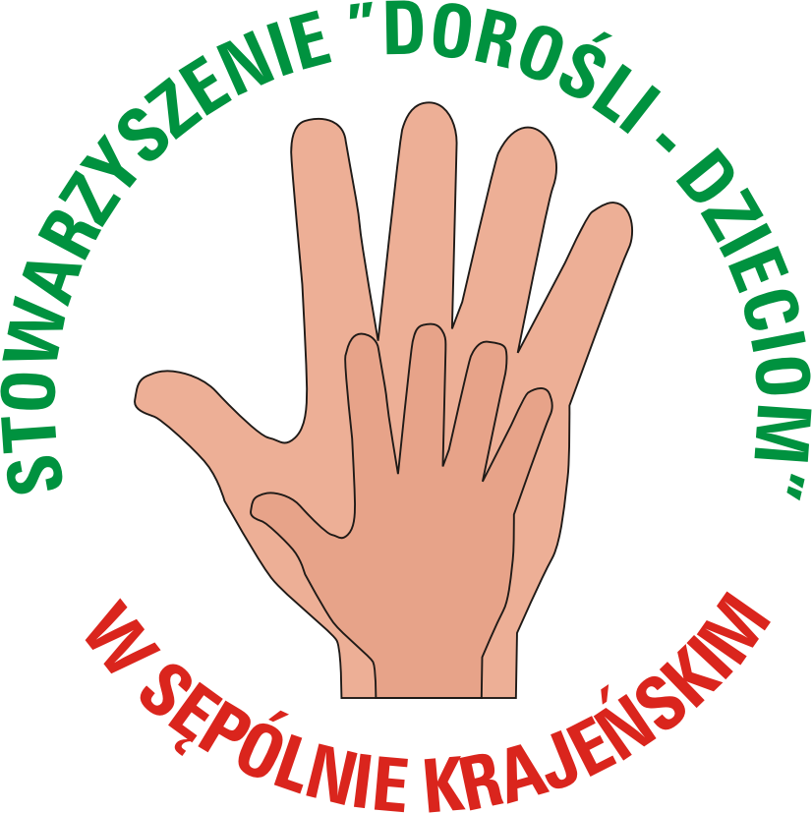
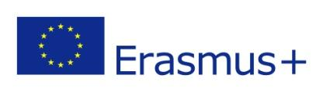

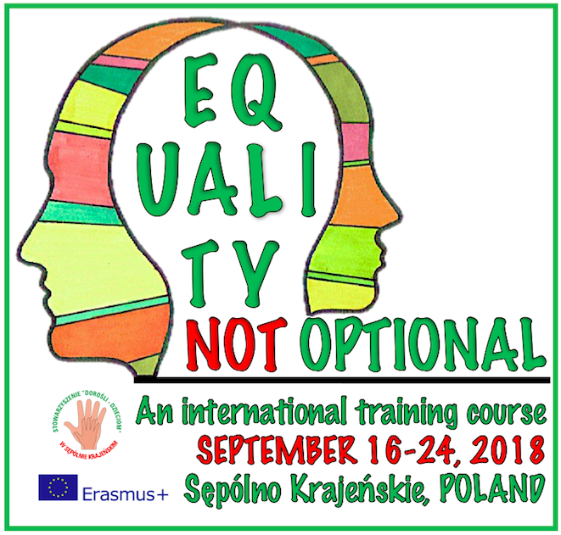

Training course for youth workers
on promoting gender equality and diversity

Info pack

DESCRIPTION OF THE PROJECT:

One of the general objectives of Erasmus+ Programme is the promotion of European values such as respect for human dignity, freedom, democracy, equality, the rule of law and respect for human rights, including the rights of persons belonging to minorities. Nevertheless, many forms of discrimination and violence related to gender and sexual orientation still prevail in our societies in Europe. Young women are particularly vulnerable, as are young people whose gender identities are marginalized and discriminated against socially and politically.
Youth workers need to realize that gender inequality is not something far away from their reality, but male-dominated, patriarchal and hetero-normative principles consciously or unconsciously influence all of us and young people in particular in their identity-making process. Young people often find it difficult to fit in traditional gender perceptions and roles and neither of the genders benefits from this robust system. Youth workers should play more active role to support young people to deal with these challenges.

With this training course we wish to remind youth workers that in order to be effective, fair, inclusive and contribute to creation of society with greater equality, gender dimension has to be taken into account during any youth work activity.
What is the difference between political correctness and respect to other people regarding gender identity? What are we so much occupied with sexual orientation and gender? What is homophobia and why is it dangerous? Why is it important for teachers and youth workers to avoid taboos and better understand SOGI? How can you address taboos with young people? If you want to find answers to these questions, this training course is made for you. After this 7 day training course you will move freely and comfortably in sexuality and gender identity and you will be able to work without taboos with young people. 21st century is here and we as youth workers need to catch up with contributing more effectively to creating inclusive and respectful communities.

OBJECTIVES that we have set for this training:
- Developing awareness and understanding about various concepts related to gender and how it connects to promoting common values in Europe and daily youth work reality.

- Understanding the mechanisms of discrimination and violence and how it affects individuals and society – with special focus on gender and how it affects young people.

- Sharing realities when it comes to respect for diversity and inclusion in the represented countries and regions paying special attention to aspects of gender equality and violence against women.

- Exploring role of youth workers and power of NFL to promote positive social change and developing skills of applying NFL tools to fight against violence and discrimination based on gender.

- Planning and implementing concrete follow-up activities to promote gender equality, diversity and inclusion at local level.

By involving in this projects, it is crucial that participants realize that we expect their active involvement not only during the training, but also in preparation activities and also follow-up activities.

Preparations
(August)
- Doing "home-works" prepared by trainers
- Discussing follow-up ideas with group/organization

Training
(16-24 September)
- Active participation in all programme activities
- Working on more detailed plan of follow-up activities

Follow-up activities in your country
(November-January)
- 2 follow-up activities with your colleagues and young people

PROFILE OF PARTICIPANTS:
Due to character of the project, it is very crucial for us that Partner organisations spread the information through suitable channels and select relevant participants (we keep the right to reject participants that do not fit the profile).

THE PARTICIPANTS SHOULD:
- Be working with young people on regular basis – as youth workers, peer-to-peer educators, activists, teachers, social workers, etc.
- Open to challenge themselves for learning in the intense programme of the training (sometimes even 12 h per day :))
- Ready to organize at least 2 follow-up activities using the experience from this training (individually or together with another person from the same country) within 3 months after the training
- Fluent in communication in English

WORKING LANGUAGE: English

Participant Countries and number of participants:

Participating countries | Number of participants
Latvia | 3 + 1 trainer
Hungary | 3 + 1 trainer
Greece | 3
Spain | 3
Portugal | 2
Estonia | 3
Italy | 3
Croatia | 3
Poland | 3 + 1 support staff
TOTAL | 29

WE ARE STILL LOOKING FOR PARTICIPANTS FROM: Latvia – 3, Hungary – 3, Spain – 1, Estonia – 3, Italy – 3, Poland – 3.
TRAVEL COSTS AND REIMBURSEMENTS:
The training course will be implemented in the framework of EU “ERASMUS+” Programme (mobility of youth workers, key action 1). The accommodation and food will be covered fully.
Travel expenses will be reimbursed at flat rates depending on travel distance:

Country of Origin | Maximum Reimbursement (in EURO, per person)
Latvia | 275
Hungary | 275
Greece | 275
Spain | 360
Portugal | 360
Estonia | 275
Italy | 275
Croatia | 275
Poland | 0

Most of you will probably arrive to Warsaw Chopin Airport but airports in Gdańsk or Poznań might be also good options (however in most cases the cheapest way is a travel to WARSAW). From Warsaw you will have to go to Bydgoszcz (train/bus tickets will be provided by organisers) and from Bydgoszcz we will pick you up to the training venue… Quite a long way but… worth all your time and efforts…

Once you have chosen a flight connection, please consult it with: Daniel Wargin - the main coordinator – daniello13@wp.pl , +48 600062665. Please note that only when he gives you “green light” for the connection and price, you are allowed to buy tickets
TRAINING VENUE AND ACCOMODATION:

Arrival to the venue: SEPTEMBER 16th, 2018  Departure from the venue: SEPTEMBER 24th, 2018  Location: Sępólno Krajeńskie , POLAND  Sępólno Krajeńskie it is a small town located in Kujavian-Pomeranian voivodship, about 350 km from the capital of Poland – Warsaw, with the population of about 10 000 inhabitants. Cozy, quiet, friendly place with the lake in the centre, surrounded by beautiful nature will be perfect place for successful learning process. |  | 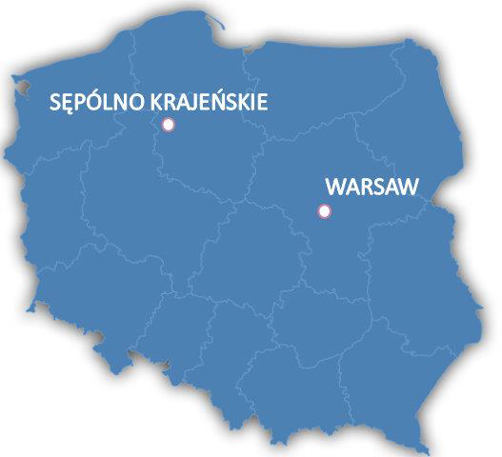
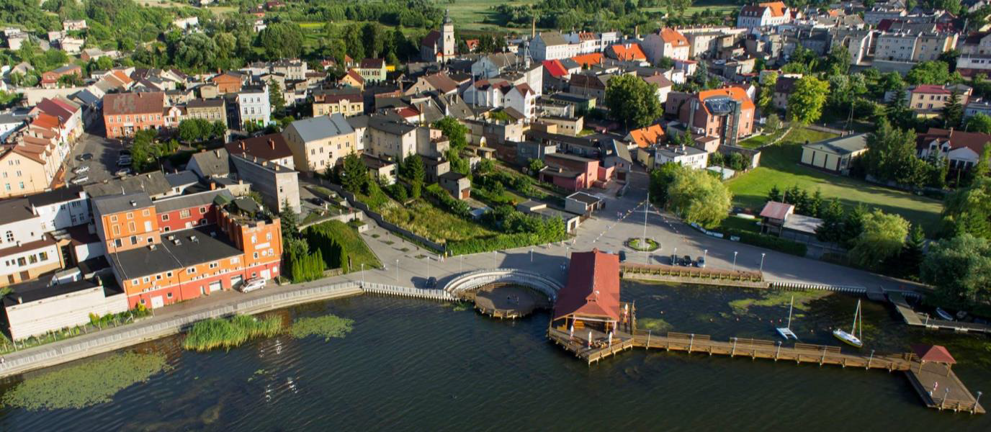
The main activities will take place in HOTEL “JAN” located at the bank of picturesque lake, surrounded by and woods and very near to the town centre. Nice atmosphere, friendly surrounding and beauty of nature – everything in one place…  Meals will be provided in the same place. | 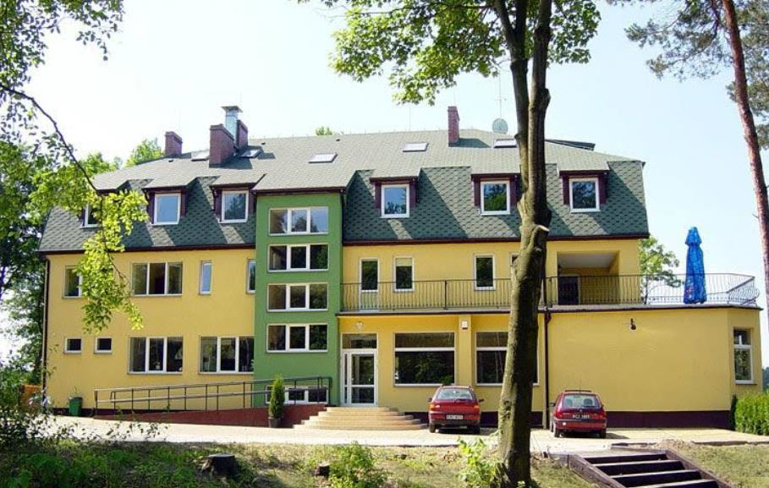
HOTEL ADDRESS:
1 Leśna street
89-400 Sępólno Krajeńskie
POLAND

HOTEL JAN will be our training venue till Saturday, September 22nd. From organizational reasons we will have to move but no worries, there will be still 2 days ahead.

We are going to move to TORUŃ – which is city located about 100 km from Sępólno. The only thing we can add now, is that it is very beautiful

TRAINERS AND COORDINATOR OF THE PROJECT:

 | 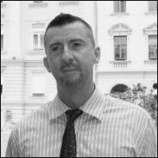 | 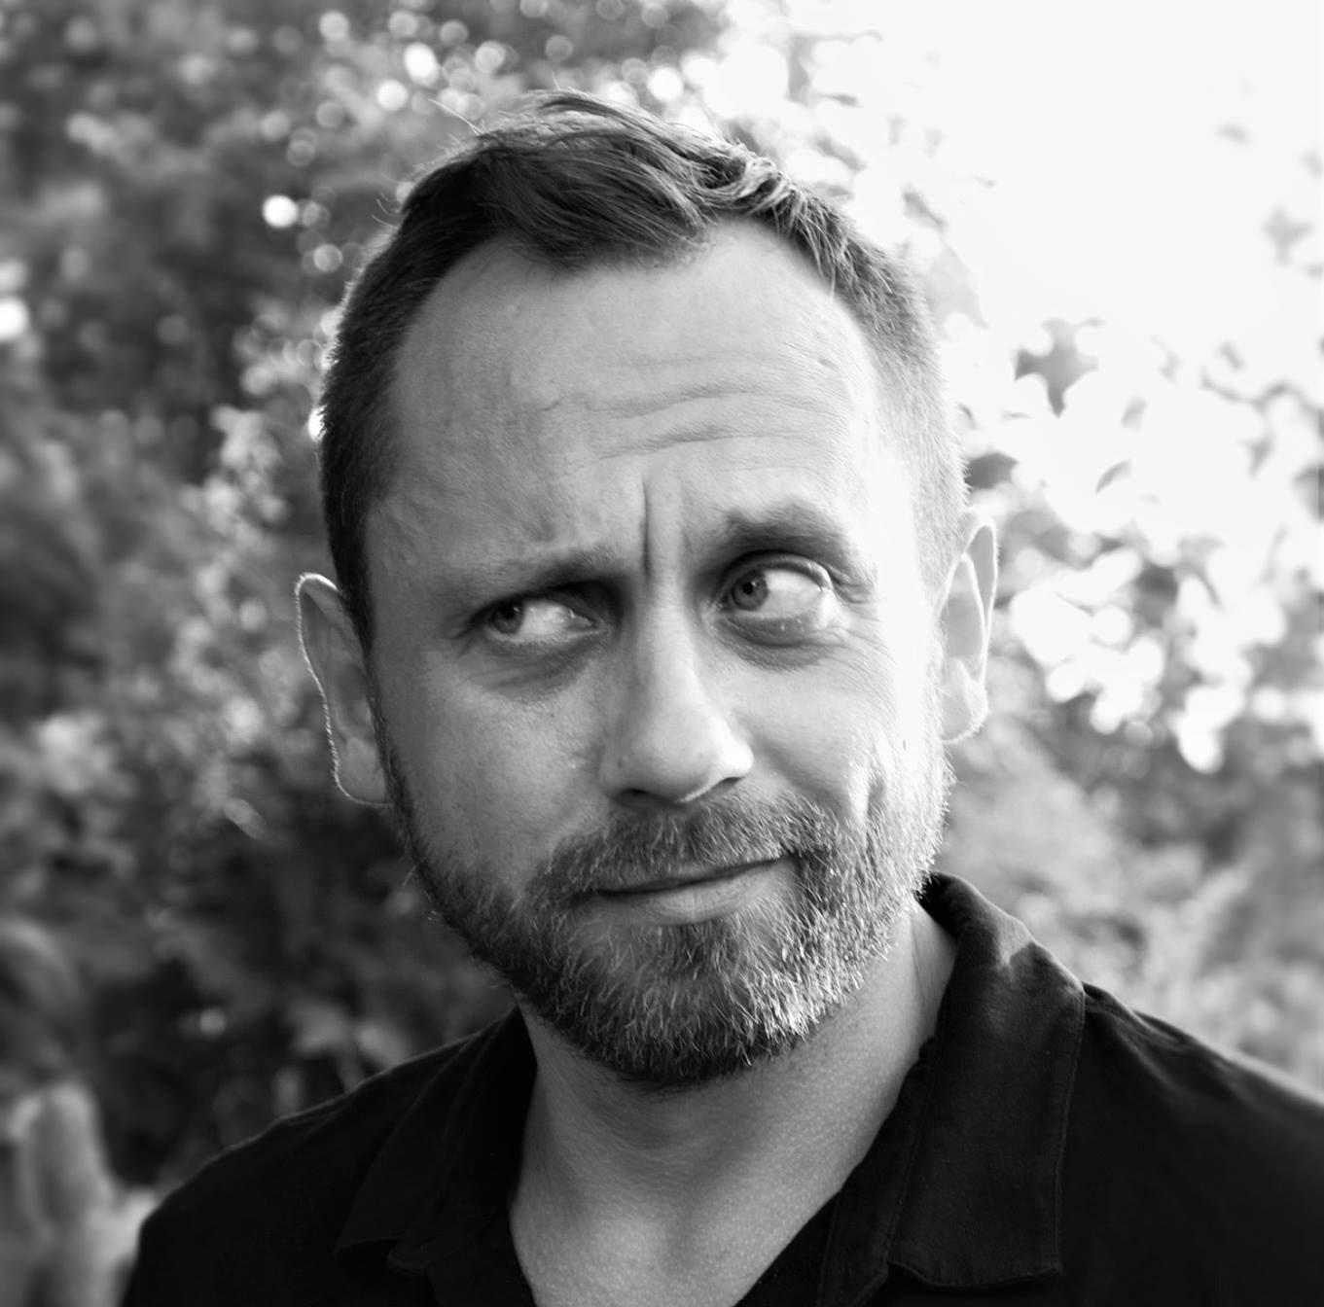
Ieva Grundsteine, trainer (Latvia) has been working in the youth field since 2001 and last 9 years is a trainer of non-formal learning in the field of youth – as a local and European project initiator and manager. She has carried already more than 100 international trainings for different target groups (youth workers, teachers and others): www.salto-youth.net/tools/toy/ieva-grundsteine.1858 | Laszlo Foldi (Hungary) is a member of the pool of trainers of the Council of Europe, and SALTO experienced in Human Rights education (part of NoHateSpeech campaign), gender identity and sexual orientation, citizenship education and education through sport has more than 15 years experience in the field. | Daniel Wargin, project coordinator (Poland) – a member of the applying organisation: Stowarzysznie “Dorośli – Dzieciom” (“Adults for Children” Association) from Sępólno Krajeńskie, Poland.  Actively involved in youth work since 2005. Coordinator of EVS projects, Youth Exchanges and training courses.

How to apply:

All you need to do is to be MOTIVATED and meet our participant’s criteria. To apply, please fill in the online application form accessible here:

APPLICATION FORM

We will be expecting the applications no later than THURSDAY, 30th of AUGUST 2018.
After considering all received application forms, the selection team will notify you upon your success (August 31st).

In case of questions, please contact: Daniel Wargin, daniello13@wp.pl or +48600062665

Looking forward to see you in Poland!

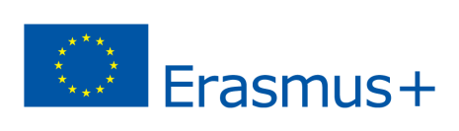
Programme (working version)
Time / day | Day 1 | Day 2 | Day 3 | Day 4 | Day 5 | Day 6 | Day 7 | Day 8 | Day 9
8.30 - 9.15 | Arrivals | Breakfast
9.30 - 11.30 |  | Intro  Getting-to-know each other  Ice-breaking | Opening discussion on understanding the concepts related to gender, diversity and inclusion etc. | Introducing non-binary gender theory and understanding sexual orientation | Non-formal learning and how to design&facilitate a NFL activity on diversity (a "crash course") | Remaining questions, intro to Laboratory phase and division in groups | Implementation of worked out tools (in 2 paralell groups; 70 min each activity) + Reflection and feedback | Planning on follow-up trainings with local youth - meetings in national groups | Farewell and departure
11.30 - 12.00 |  | Coffee break
12.00 - 13.30 |  | Programme, approach, motivation and Youthpass | Understnding Inequalities and Exclusion | Gender-based discrimination and violence (analyzing the situations from youth work contexts) | Exploring local realities related to prejudices related to gender - LIVING LIBRARY with local community and youth | Practical part: Laboratory of tools – developing NFL activities to promote gender equality | Implementation of worked out tools (in 2 paralell groups; 70 min each activity) + Reflection and feedback | Continuation of work, presenting follow-up ideas and peer-to-peer support
13.30-15.30 |  | Lunch
15.30-17.00 |  | Group-building activities through games | Gender - everybody's issue - exploring own gender identity and sharing stories | Gender-based discrimination and violence (analyzing the situations from youth work contexts) | Exploration and free time in Sepolno Krajenskie | Practical part: Laboratory of tools – developing NFL activities to promote gender equality | Implementation of worked out tools (in 2 paralel groups; 70 min each activity) + Reflection and feedback | International opportunities of cooperation - NoHate Speech Campaign, "Humans of Diversity", brief outline of Erasmus+ programme and resources, etc.
17.00 - 17.30 |  | Coffee break |  |  |  | Coffee break
17.30 - 19.00 | Getting to know each other | Group-building activities | Sharing local realities on issues with diversity and gender equality in youth work context | Role of youth workers to promote gender equality and underlying competences |  | Implementation of worked out tools (in 2 paralell groups; 70 min each activity) + Reflection and feedback | Summing up Lab phase - sharing experiences from both groups, Q&A, recommendations for future activities with youth | Reflections on Learning Summing up  Evaluation  Closing
19.00-19.30 |  | Time for reflection in group |  |  |  | Time for reflection in group
20.00 | Welcome Dinner | Dinner |  |  |  |  |  | Farewell dinner and evening
After 21.00 |  | Integration evening | Intercultural Diversity Evening | Free evening | Polish Dinner | Free evening | Self-organized evening

